Name: Kashish Goel
Internship: Celebal Technologies Internship
Domain: Data Engineering
Week: 6
Assignment: Apache Spark Architecture and Data Processing
Q1: Explain the roles of the Driver, Cluster Manager, and Executor in a Spark application.
The Driver is the process that runs the application's main() function. It builds the SparkSession, converts the code into a DAG of stages and tasks, and schedules that work — it does not process data itself.
The Cluster Manager (e.g. YARN, Kubernetes, Spark Standalone) sits between the Driver and the physical machines. It negotiates resources and launches Executors on worker nodes based on what the Driver requests.
Executors are the worker processes that actually run tasks and hold data in memory/disk for that application (via caching/shuffle). Each Executor reports task status and results back to the Driver, which assembles the final output.

Q2: How does Spark’s Lazy Evaluation strategy improve performance when chain-processing large datasets?
Transformations (select, filter, withColumn, join, etc.) don't execute immediately — Spark just records them as a logical plan (the DAG/lineage graph). Execution only happens when an Action (show, count, write, collect) is called.
Because Spark sees the whole chain of transformations before running anything, its Catalyst optimizer can rewrite the plan for efficiency: combining multiple filters into one pass, pushing filters/column pruning down to the data source, reordering joins, and skipping columns or partitions that are never used. This avoids materializing intermediate results and reduces the actual amount of data read and shuffled, which is far more efficient than running each step eagerly.

Q3: Write a Spark command to read a CSV file located at "data/source.csv", ensuring the first row is treated as a header and inferSchema is enabled.

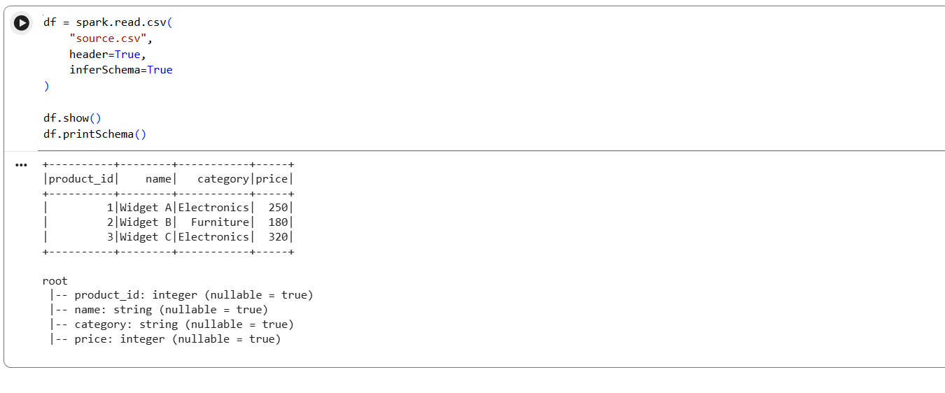

header=True tells Spark to treat the first row as column names instead of data. inferSchema=True makes Spark do an extra pass over the file to detect data types (int, double, string, etc.) instead of defaulting every column to string.

Q4: What is the difference between CSV and Parquet in terms of storage (row-based vs. columnar) and why does it matter for performance?
CSV is row-based: each row is stored fully, one after another as plain text. To read even a single column, Spark must scan and parse every row in full.
Parquet is columnar: values for each column are stored together in contiguous blocks, along with per-column metadata (min/max, type, compression). This matters for performance in three ways: Spark can read only the columns actually needed (column pruning), it can compress each column far more effectively since values in a column are similar in type/range, and it can skip whole row-groups using stored statistics (predicate pushdown) — all of which drastically cut I/O compared to CSV.

Q5: Given a DataFrame df, write a query to select the columns product_id and price where the category is 'Electronics'.
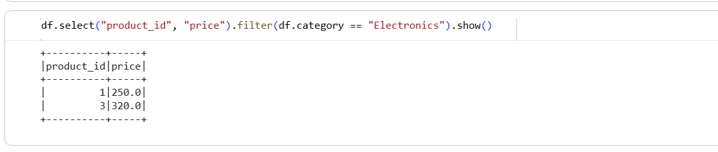
Q6: Write the code to "revise" a DataFrame by renaming the column old_name to new_name and casting the price column from a String to a Double.
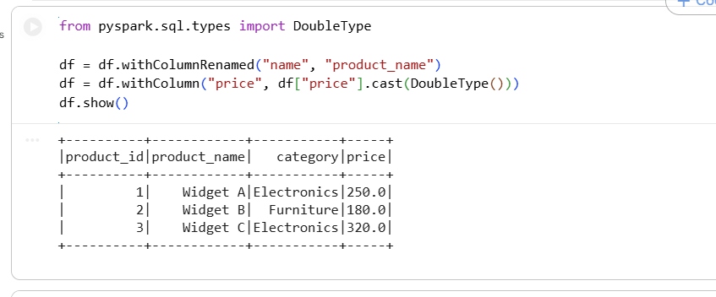
Q7: How does Spark use the Lineage Graph (DAG) to provide fault tolerance if a worker node fails?
Every RDD/DataFrame keeps track of the sequence of transformations used to build it from the original source — this is its lineage. Because the DAG records exactly how each partition was derived, Spark doesn't need to replicate data across nodes for safety.
If a worker/executor fails and loses some partitions mid-job, the Driver simply reschedules only the lost tasks on another executor, recomputing those partitions from the lineage graph (starting from the last stable point, e.g. a cached/shuffled stage) instead of restarting the whole job. This lineage-based recovery is what gives Spark fault tolerance without needing constant data replication.

Q8: Write a query to filter a DataFrame df_orders for rows where the status is 'Completed' AND the amount is greater than 1000.
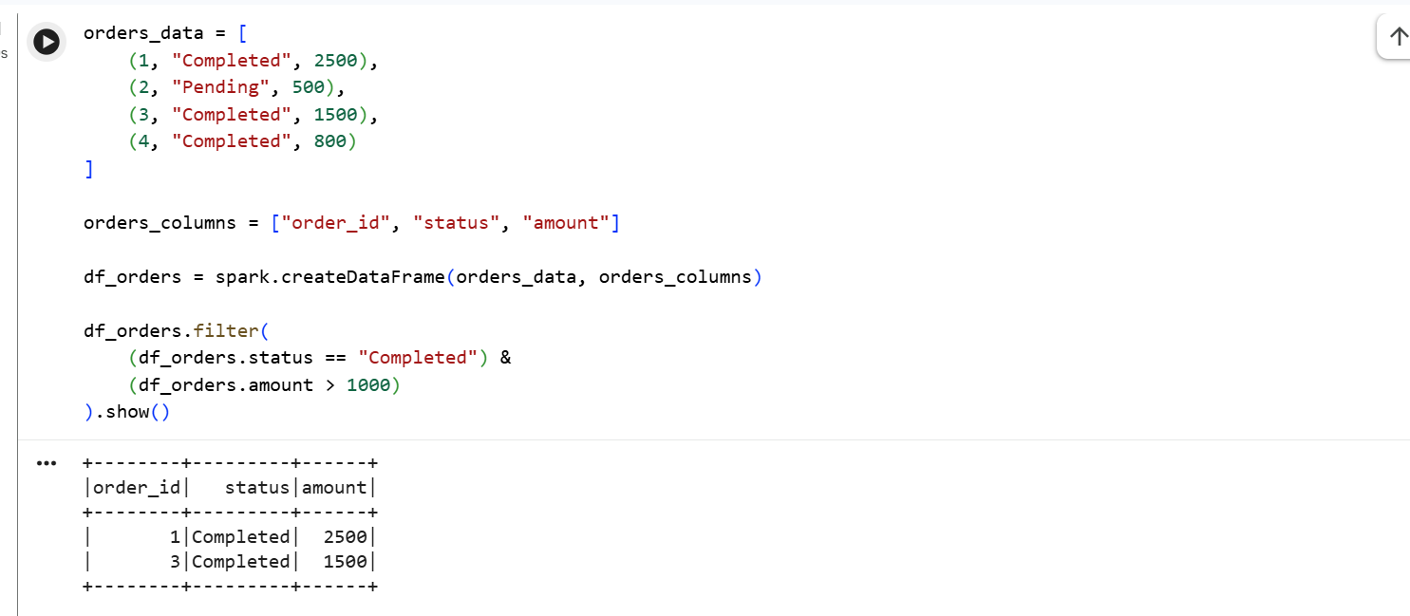
Q9: Explain the concept of Predicate Pushdown in Parquet and how it affects the amount of data loaded into memory.
Predicate pushdown means the filter condition in your Spark code (e.g. .filter(col > 100)) is pushed down to the file-reading layer instead of being applied after all data is loaded into memory. Parquet stores min/max statistics for each column per row-group, so Spark's reader can check the predicate against those statistics and skip entire row-groups that can't possibly match — those blocks are never even read off disk.
The effect is that far less data is deserialized and pulled into executor memory, which reduces I/O, network/shuffle volume, and memory pressure — especially valuable on large datasets where only a small fraction of rows satisfy the filter.

Q10: Write a code snippet to add a new column final_price which is the base_price multiplied by 1.18 (18% tax).
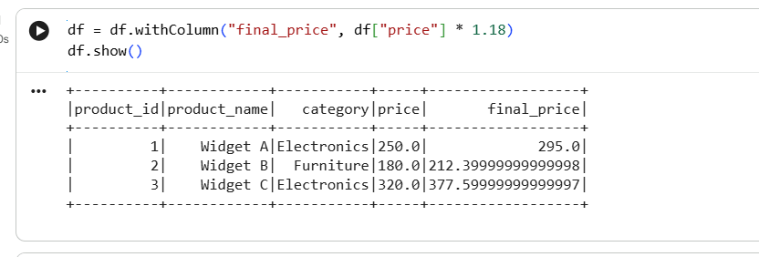
Q11: What is the difference between Transformations and Actions? Provide two examples of each.
Transformations are lazy operations that define a new DataFrame/RDD from an existing one without executing anything immediately — they just extend the DAG. Examples: filter(), select(), withColumn(), groupBy(), join(), orderBy().
Actions trigger the actual execution of the DAG built so far and return a result to the Driver or write output. Examples: show(), count(), collect(), write.csv(), take().

Q12: Write the Spark command to load a Parquet file from "path/to/input", filter out any rows where user_id is null, and save the result as a CSV at "path/to/output".
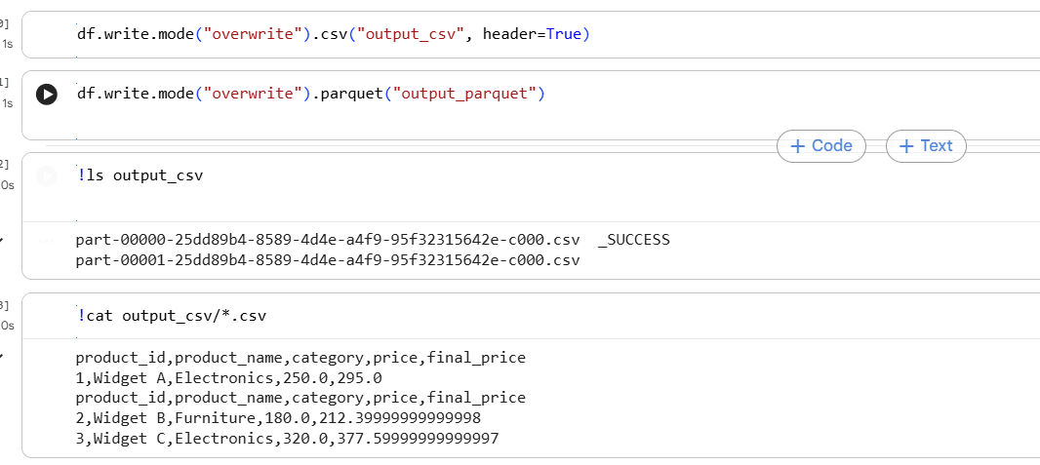
Q13: In Spark Architecture, what is the difference between Client Mode and Cluster Mode?
In Client Mode, the Driver runs on the machine that launched the application (e.g. your laptop or an edge node), outside the cluster, while Executors run on the cluster. This is convenient for interactive work (notebooks, spark-shell) but the Driver — and the whole job — dies if that client machine disconnects.
In Cluster Mode, the Driver itself is launched inside the cluster (on a worker node), managed by the Cluster Manager. The submitting machine can disconnect once the job is submitted. This is the standard mode for production/scheduled jobs since it's more resilient and doesn't depend on the client staying connected.

Q14: Write a query to filter a dataset for rows where the region is 'North' OR the priority is 'High'.
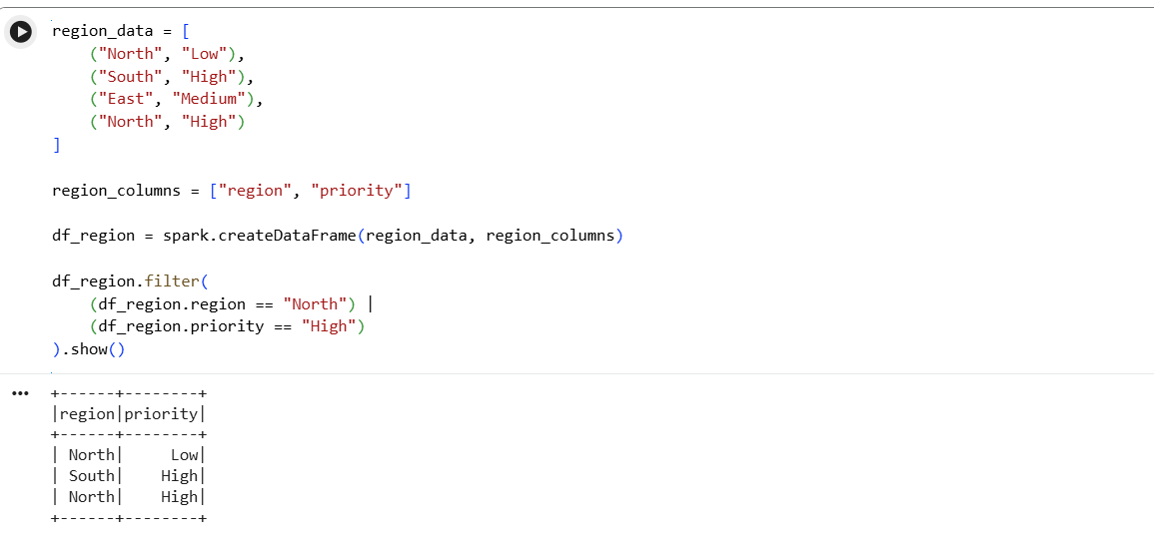
Q15: When exploring a dataset, why is it safer to use .show(5) instead of .collect() on a multi-terabyte dataset?
.collect() pulls every single row from all executors back to the Driver's memory. On a multi-terabyte dataset, this will almost certainly exceed the Driver's memory and crash the application (or bring down the cluster driver process) since the Driver isn't sized to hold the full dataset — only to coordinate work on it.
.show(5) instead asks Spark to compute and display just the first 5 rows, and — because of lazy evaluation — Spark is smart enough to only read/process as much data as needed to produce those 5 rows rather than materializing the entire dataset. It's the safe way to sanity-check a DataFrame's structure and contents on large data.

